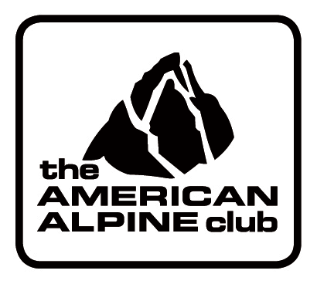

Chris “Haliku” Pruchnic
Wilderness First Responder Training Grant

APPLICATION

Submit application to:
Grants Manager
Attn: Pruchnic Grant
Email: grants@americanalpineclub.org
Phone: 303-384-0110 ext. 15

In order to process your application as quickly as possible:

- Submit electronically in MS Word or PDF formats. You must include a valid scanned signature inserted into the document where needed or send a signed copy of this application by post as well.
- Type or print clearly
- Submit to the AAC on or before the January 31 deadline.

Name: _____________________________________ Date of Birth ______________________

Address: _____________________City: ________________State:____ Zip: ______________

Primary Phone: ______________________Email: ___________________________________

Proposed Trip Destination _____________________________Dates of Trip ______________

___ Yes, I am a member of The American Alpine Club (membership is required). Go to the AAC website to sign up for membership. Under age 29 is considered a Junior Membership and is a reduced membership fee.

___ Yes, I am a U.S. Citizen

___ Yes, I am a resident of the Rockies Region (Climbers from Colorado, Wyoming, New Mexico and Utah are eligible).

- Explain in less than 500 words how your training will be shared with and used to benefit others, not only in terms for rendering first aid, but in the spirit of sharing and community return. *If the reason you are needing training is because you are working with a volunteer organization, please also provide a letter of support from the organization indicating what amount of time the individual works or volunteers with the organization and really briefly how the training would help the organization.

- Attach a copy of the accredited WFR program you intend to attend. A copy of the application to the program when you apply may be supplied after grant is awarded.

By my signature, I agree that:

- All of the information presented in this application is true and accurate.

- Any awarded funds will be used for the purposes stated and that any changes in plans will be reported to the Pruchnic Grant Committee and to the AAC.

- If for any reason the award cannot be used, awarded funds must be returned to the AAC.

- I will be responsible for any taxes that may apply to the award received.

- I will provide a copy of my certification within 13 months of the application date.

SIGNATURE: ______________________________________DATE:____________________

PRINT NAME: _____________________________________

We must have your signature. If you can’t provide an electronic signature, please mail a backup signed copy to the AAC offices at: 710 10th Street, Golden, CO 80401 Attn: Grants Manager.

Before grant funds can be distributed to recipients, a signed and initialed “Agreement” between grant recipient and the AAC must be received along with recipient’s social security number (for tax purposes). This form will be sent to winning grant recipients with notification that they have been awarded a grant. An electronic signature or mailed in signature on this form will be required.

