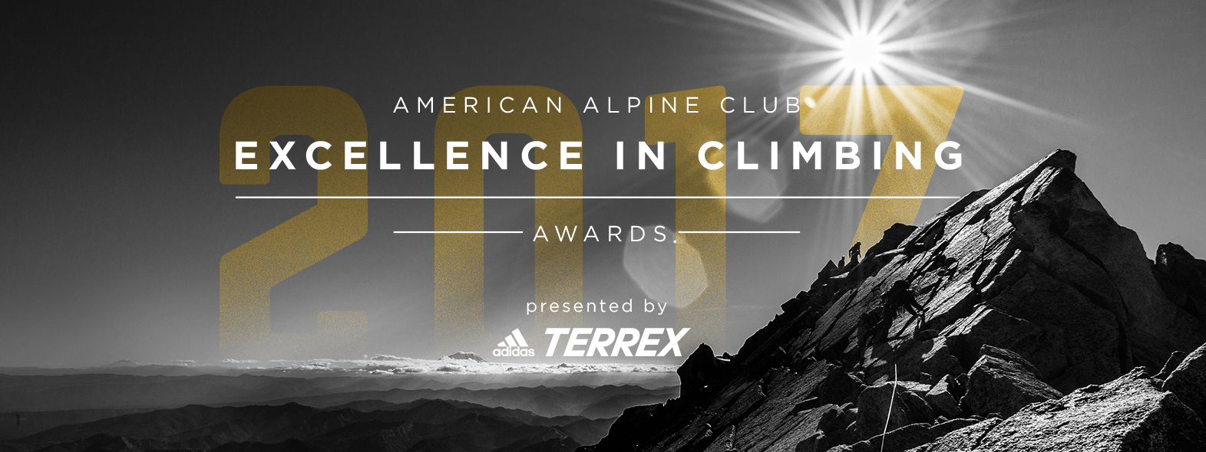

LOOK WHO’S COMING
On SATURDAY, JUNE 3

TABLE LEVEL SUPPORTERS
Adidas
Kevin and Leanne Duncan
Dave Landman
Cody Smith

PATRON SUPPORTERS
George Basch
Carey Roberts

Sam Andree
Melissa Arnot Reid
Mia Axon
Stacy Bare
George Basch
Jill Barker
Jim Barker
Scott Bennett
Luis Benitez
Sydney Bernard-Hogling
Matthew Biscan
Greg Block
Jeff Blumenfeld
Sterling Boin
Steve Bonowski
Whitney Bradberry
Tiffany Brainerd
Donald Brier
Deanne Buck
Mark Butler
Diane Campbell
RJ Campbell
Kayleen Castelli
Brad Clement
Tonya Clement
Jay Cordes
Matt Culberson
Kit DesLauriers
Ian Dory
Kevin Duncan
Leanne Duncan
Ken Ehrhart
Asa Firestone
Stephen Gould
Loren Gwartney-Gibbs
Natalie Gwartney-Gibbs
Marian Hawley
Diane Heasley
David Hite
Art Hogling
Vickie Hormuth
Tom Hornbein
Kathryn Hornbein
Krista Howard
Sharon Houghton
Shane Johnston
Nickie Kelly
Carol Kotchek
Philip Kranz
Phil Lakin
David Landman
Tyler Landman
Linda Lawson
Cathy Lockyear
Chris Lockyear
Vanessa Logsdon
John Long
James Lucas
Randolph Luskey
Charley Mace
Leonard Madrid
Bryan Martin
Anne McGuire
Heidi Medema
Peter Metcalf
Kathryn Moore
David Morton
Matt Murray
Michael Neustedter
Sean O’Connell
Matt Ochs
Suzanne Ochs
Sean O’Neill
Timmy O’Neill
Alison Osius
Scott Paramski
Elysa Polovin
Maria Povec
Phil Powers
Lisa Prassack
Sherry Richardson
Carey Roberts
David Robertson
Janet Robertson
Scott Robson
Jess Roskelley
John Roskelley
Chelsea Rude
Vik Sahney
Dave Schaffer
Steve Schofield
Dee Schofield
Catherine Sheehe
John Soebbing
Rebecca Soebbing
Matt Stevens
Steve Taylor
Chris Tomer
Dirk Tyler
Sarah Van Beckum
Nancy Warner
Rick Warner
Elizabeth Weathersby
Brad Wells
Heidi Wells
Alice White
Matt Whittaker
Nina Williams
Keegan Young
Graham Zimmerman
Margaret Zyzda
Michael Zyzda

Updated May 24, 2017.

