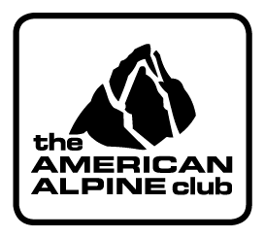
THE ZACH MARTIN BREAKING BARRIERS GRANT
APPLICATION

Submit application to:
Grants Manager
Attn: ZMBB GRANT
Email: grants@americanalpineclub.org

In order to process your application as quickly as possible:

- You must submit your application electronically in MS Word or PDF format.
- Submit to the AAC on or before the April 15th deadline.

Name: (last, first, middle)_________________________Date of Birth: _____________

Address: ______________________City: _________________State: Zip:__________

Primary Phone: __________________________ Email: _______________________________

___ Yes, I am a member of The American Alpine Club

___ Yes, I am a U.S. Citizen (applicant must be a U.S. citizen but team members need not be.)

Dates of Trip _____________________
*Please alert Grants manager once travel dates are finalized.

TITLE OF GRANT PROPOSAL: ______________________________________

HUMANITARIAN OBJECTIVE: (Succinct and concise discussion of importance, need, continuity, 300-400 words). The humanitarian objective must be reasonable, and sustainable. Objectives that continue after implementation will receive the highest level of consideration. Focus the objective to affect the greatest human change.

ALPINE OBJECTIVE: (A concise and definitive statement of the objective, purpose, scope, etc. 200-300 words) The alpine objective should focus on climbing and exploration but need not be at the leading edge of climbing or alpinism.

TEAM MEMBERS (Names, qualifications, experience, etc. 100-200 words):

ADDITIONAL GRANTS OR SPONSORSHIPS you are applying for:

